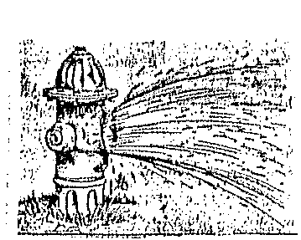
Notice is hereby given that the City of Winchester will be flushing Fire Hydrants starting May 26 – June 5, 2020. There will be some discoloration of water during this time since flushing the fire hydrants will stir up sediment. The City recommends any resident doing laundry during this time period to fill washing machines first to check water conditions. The water department thanks all City residents for their patience and cooperation during the flushing process.

