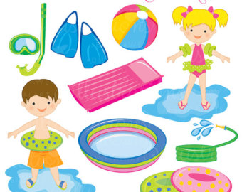  JUly 3-14  SWim Camp 2017  Swim Camp  Swim Camp 2017 is a great way to improve your kids swimming skills. Each day the kids will start by working on a specific stroke, with a goal to better their stroke everyday. After drills the kids will have a game that will improve their confidence in the pool. The games are intended to get the kids to work together as a team, build swimming skills, and most importantly have fun and be safe around water! The kids are scheduled to play 2 games a day along with stroke development. | Swim Camp 2017  ────  Be Ready for Games, Friends, & Fun  ────  Improving Stroke  ────  Team Building Skills  ────  Active Summer Time Fun!  WInchester pool  Park Street, Winchester IL  (217)742-3622  July 3-14

